Things you need:

Steering Wheel
airbag and
clockspirng.

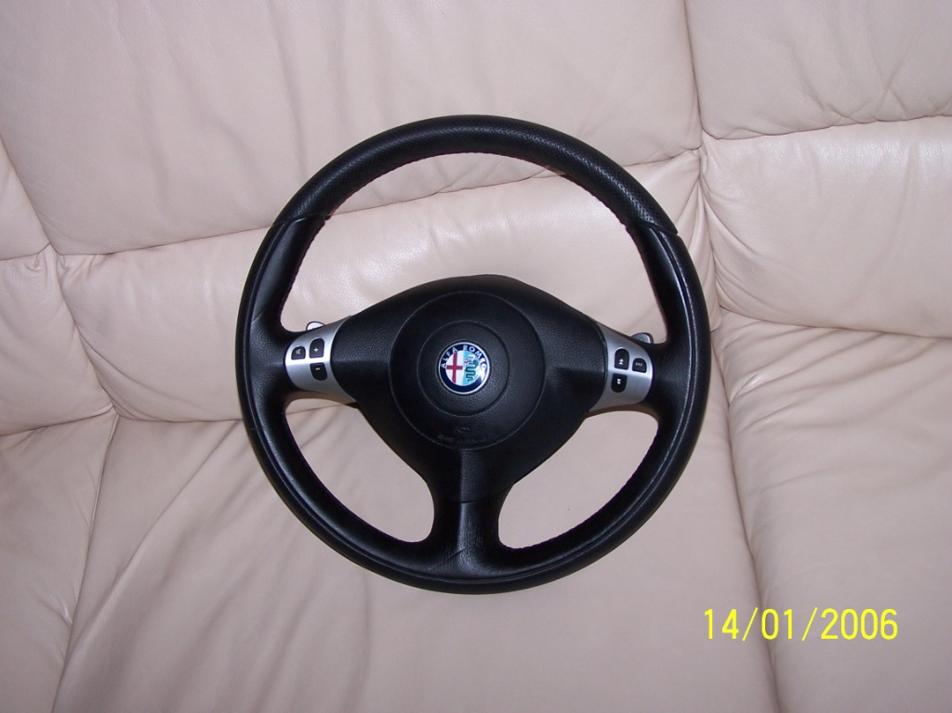
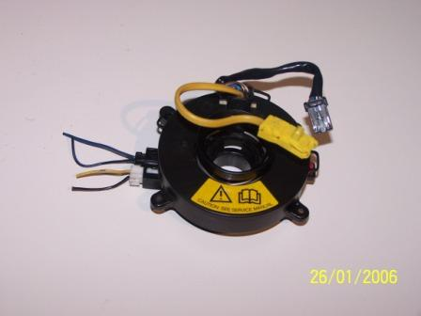

It’s also handy to get the plug which goes from the clockspring to the audio control, airba, selespeed and mass wires. See picture:
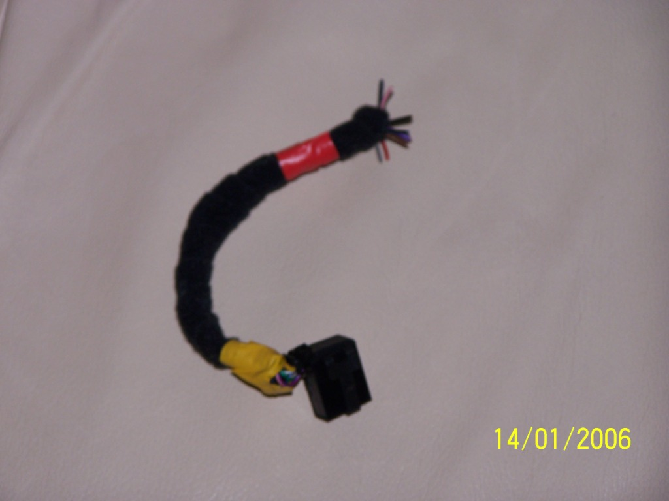

For the removal of the steering Wheel:
1) Disconnect the batery and wait 10minutes!!!
2) Make sure your steering wheel is in a straight position
3) Remove the screws on the bag of the airbag (inbussleutel ??? nr. 5)
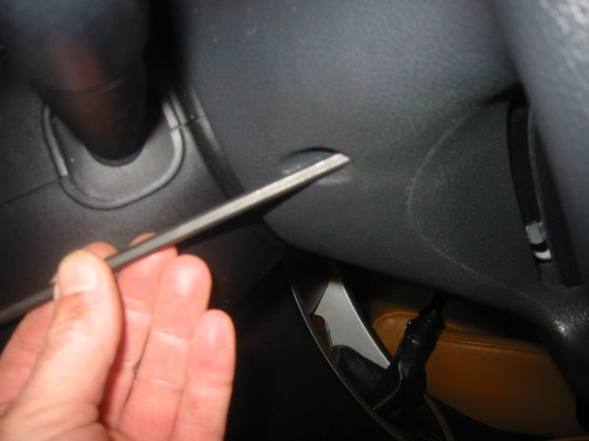
4) Carefully remove the yellow plug from the airbagunit!!!! BE CAREFUL!!!!!
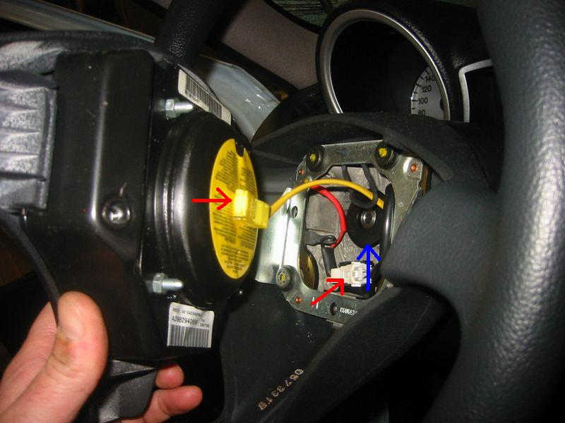

5) When the airbagunit is gone, diconnect all the plugs which you see in the steering Wheel.
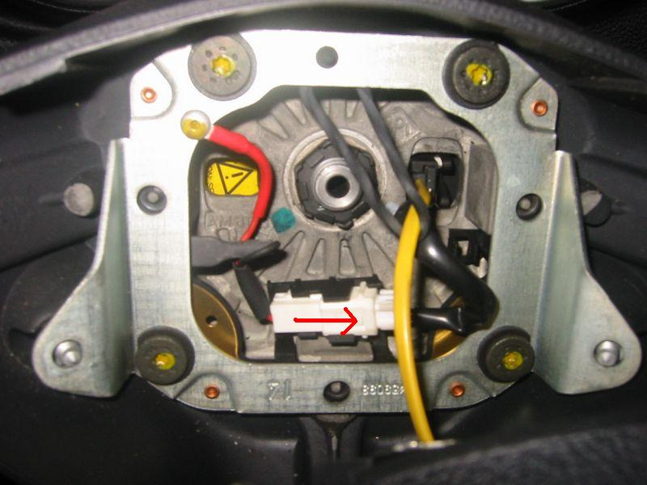

6) Disconnect the steeringwheel with a screwdriver nr. 24, when the wrench is lose carefully turn the steeringwheel to get it lose. Carefully pull it towards you. Whatch out for the clockspring behind the steeringwheel. It is connect to the airbag/ selespeed wires. So when you pull the steeringwheel to hard you will pull the clockspring with it forward and it might get destroyed. SO AGAIN BE CAREFUL.
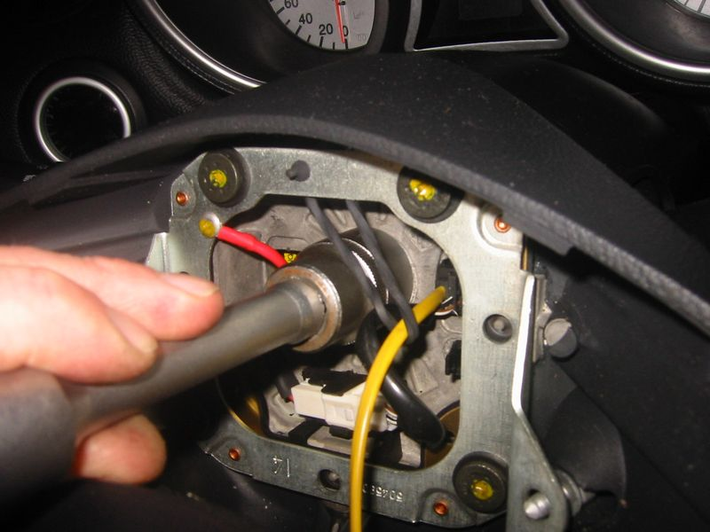

So now the steeringwheel is removed, we start with the electronics

1) Remove the old plugs which go TO the clockspring!!! Don’t remove the plugs which go from the clockspring to the steeringwheel!! (there are 2: 1 airbag/ 1 selespeed), just cut them of. The will be connect to the plug which goes to the clockspring 2)

2) The horn has no wires now, wires fort hem you will get from 2 plugs which are in this item:

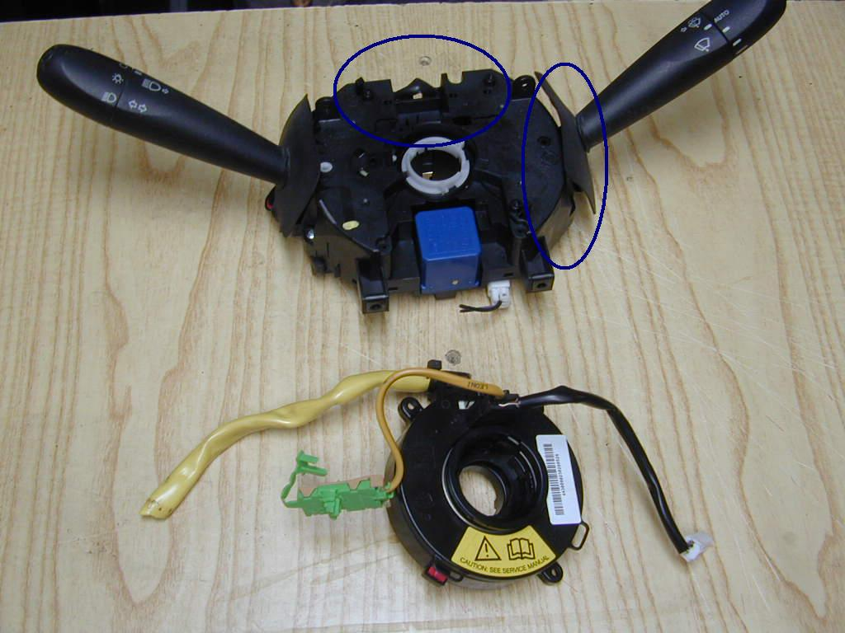

You will need plug D pin 5 and plug A pin 7

3) The mass wire you can ge trom anywhere.

See for exact plugs and pins this scheme:

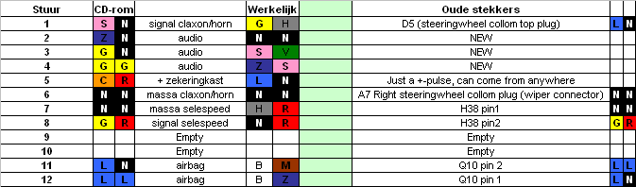

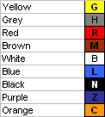

NOTE!!!: Behinf the old clockspring there are 2 contacts for the horn/claxon (gold colored), you must place ducktape over this otherwise you will kep a constant mass (electricity). If you won’t do this the horn won’t stop making noise.

I’m still busy with the audio, this will be done this weekend!!!

